Title of the paper (Pt, Fr or English)
Author, SURNAME¹, Author SURNAME², Author SURNAME³
- University - Research Program or College, City, Country
e-mail
- University - Research Program or College, City, Country
e-mail
- University - Research Program or College, City, Country
e-mail
AXIS SELECTED : NAME IT (English or Portuguese)
Abstract. Considering the thematic, the proposal, the objectives and the theoretical guidelines for developing this paper, one shoud prepare an abstract no longer than 200 words to express the general idea of this paper (only in English).
Keywords: architecture, kinesthesia, sensitiveness, experience. (4 keywords mandatory, in English)

INTRODUCTION (name it as you want - Pt, Fr or English)
Counting the words from the ABSTRACT until the ACKNOWLEDGMENTS, this paper should be between 3000 and 9000 words. From the INTRODUCTION to the end of the paper, one must choose the best language to express him/herself (English, Portuguese or French).
Figures may be included freely but the paper cannot exceed 15 pages.
10MB maximum size of papers.
In fact, ambiances contain sensory stimuli that induce interactions in the spaces, and become the reflections and the means through which individuals explore and express relationships – interspatial, interpersonal, sociocultural, subjective – thus establishing a reciprocal exchange with the Other.
As we reflected on this, it became clear that a key element in this spatial experience would arise regardless of the collectivisation of the experience; it could be evoked through a specific condition which due to the familiarity with the cognitive memories would produce an important link to the understanding of the ‘local atmosphere’. We called it ‘spatial empathy’, a terminology, as we will show below, consistent with the research in the fields of psychology and cognitive neuroscience.

Chapter 1 (name it as you want - Pt, Fr or English)
This chapter embraces the theoretical basis of this paper and should be constructed in one single chapter. Authors should explaim if the proposal will focus on practical interventions or theoretical analysis, without outlining a specific kind of intervention.

Chapter 2 (name it as you want - Pt, Fr or English)
This chapter may present the methodology or the system of steps that lead to an analysis of previous works or contexts. This is only a suggestion and all authors are encouraged to work freely in the development of the strucuture.

The Studies of Helio Oiticica
The artist's work is characterized by his innovative experiences that include public participation and are often accompanied by theoretical elaborations. But what makes the originality of his work, in its beginnings considered neo-concrete and visual (1954), appears in its second phase, more sensory and itinerant (1963) with its 'parangolés' and 'penetrable'. His 'sensory acclaim' was recognized by his experience in London, called the Whitechapel Experience (Figure 1), which featured his project Eden.

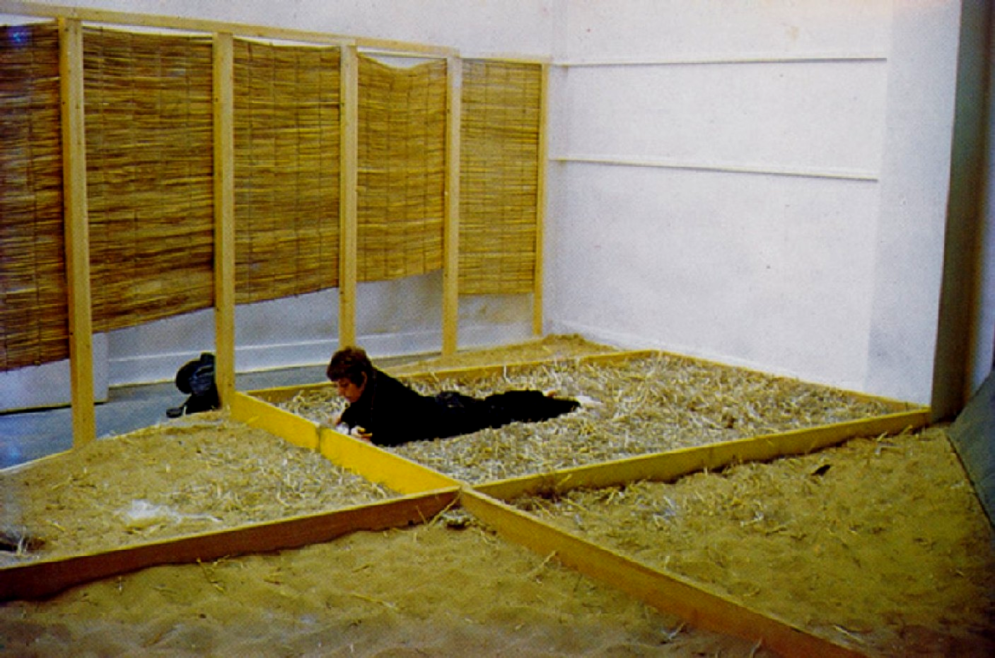

Figure 01: Bólide-ninho. Source: www.itaucultural.org.br/aplicexternas/enciclopedia

Chapter 3 (name it as you want - Pt, Fr or English)
This chapter may present the idea of the experiment, the processes suggested for developing the ‘resensitization’ or the contexts that reenforce a theoretical approach. This is only a suggestion and all authors are encouraged to work freely in the development of the strucuture.

Final Considerations (Pt, Fr or English)
The multisensory and multilocal experience of the body helps us understand the way that our corporeal existence, rich in its multiplicity, strengthens the existential and spatial experience, the feeling of ‘being-in-the-world.’
This view of the world is similarly analysed by Tixier (2004, p. 115) when he explains that the space around all living beings is not an object meant exclusively for observation, to be seen with the eyes but with all senses.

Acknowledgments (Pt, Fr or English)
We gratefully acknowledge the financial support of CNPq (National Council for Scientific and Technological Development, Brazil).

References (only the authors mentioned in the paper)
ARNHEIM, R. (2001), La Forma Visual de la Arquitectura, Barcelona, Gustavo Gili.
BAUDRILLARD, J. (1991), Simulacro e Simulação. Lisboa, Relógio d’Água.
BAUMAN, Z. (1998), O Mal-estar da Pós-modernidade. Rio de Janeiro, Jorge Zahar Ed.
BRUZZI, H.(2001), Do Visível ao Tangível: em busca de um lugar pós-utópico, Belo Horizonte: C/Arte
CARDOSO, I. (1985), A arte Penetrável de Hélio Oiticica, Folha de São Paulo, São Paulo, pp. 48-49.
FAVARETTO, C. (1992). A invenção de Hélio Oiticica. São Paulo, Edusp.
LEACH, N. (2001), La an-estética de la arquitectura, Trad. Fernando Quesada, Barcelona, GG.
MERLEAU-PONTY, M. (2000), O Visível E O Invisível, Trad. José Artur Gianotti et Armando Mora d`Oliveira, 4. ed. São Paulo, Perspectiva.
OITICICA, H. (1986), Aspiro Ao Grande Labirinto, Rio de Janeiro, Rocco.
SERRES, M. (2001), Os Cinco Sentidos, Rio de Janeiro, Bertrand Brasil.

Authors
Cristiane Rose DUARTE, Architect and Urban Designer, Full Professor at the Architecture and Urban Planning School of the Federal University of Rio de Janeiro, Phd Degree at l´Université de Paris – I, coordinator of ‘Architecture, Subjectivity and Culture’ Research group - LASC. crduarte@ufrj.br

Ethel Pinheiro, Architect and Urban Designer, Associate Professor at the Architecture and Urban Planning School of the Federal University of Rio de Janeiro, Phd Degree at Proarq/Ufrj, coordinator of ‘Architecture, Subjectivity and Culture’ Research group - LASC. ethel@fau.ufrj.br

Footnotes are wellcome.

